PROJECT REPORT ON PLAGIARISM AND AI

PLAGIARISM

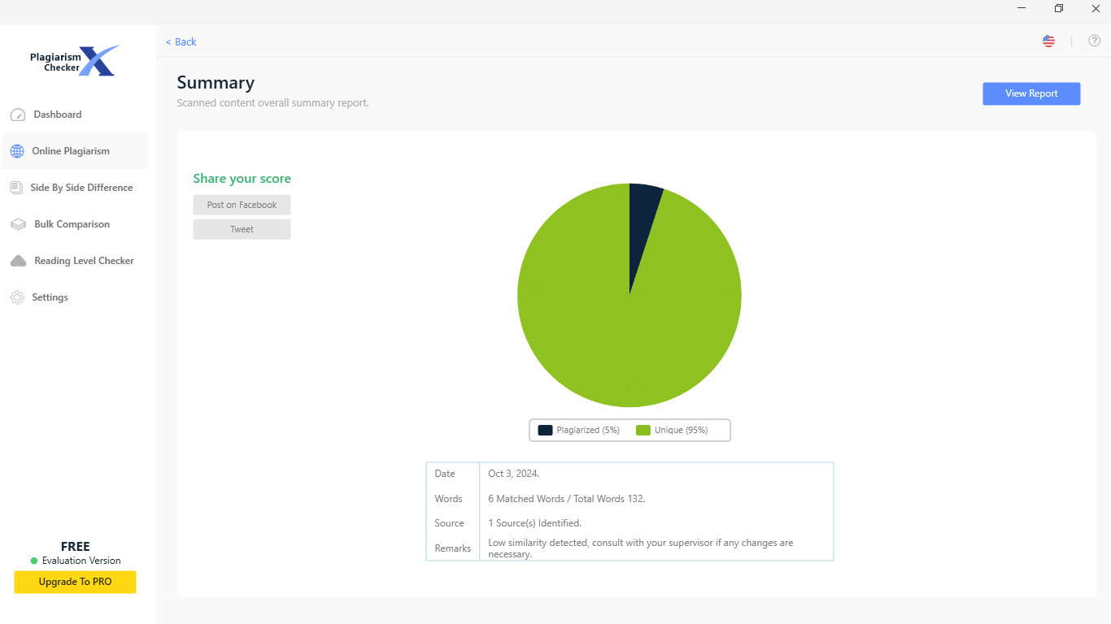

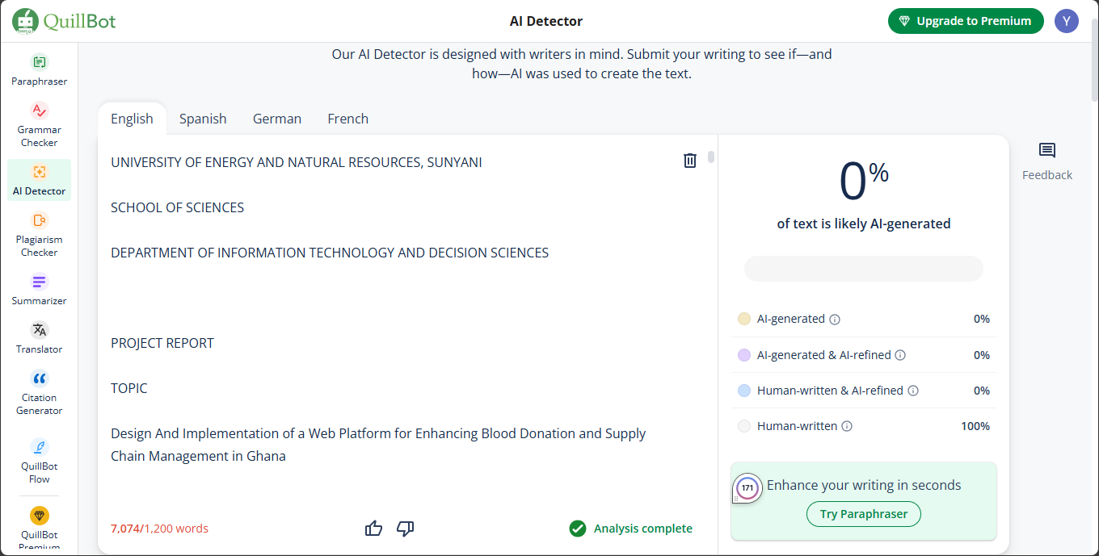AI